

**Market Overview Dashboard Design for Excel**

Based on my analysis of institutional trading desk layouts and market pulse indicators, I've designed a comprehensive **post-market close dashboard** that combines professional-grade market analysis with Excel's accessibility. Here's your complete dashboard design with mock data:

**🎯 Dashboard Overview**

The dashboard is structured as an **executive summary** optimized for quick decision-making after market close, featuring:

* **8-section layout** covering all critical market aspects
* **Professional color coding** (🟢 Bullish, 🟡 Caution, 🔴 Bearish)
* **Real-time indicators** including after-hours data
* **Institutional-grade signals** (GMI, breadth, sector rotation)

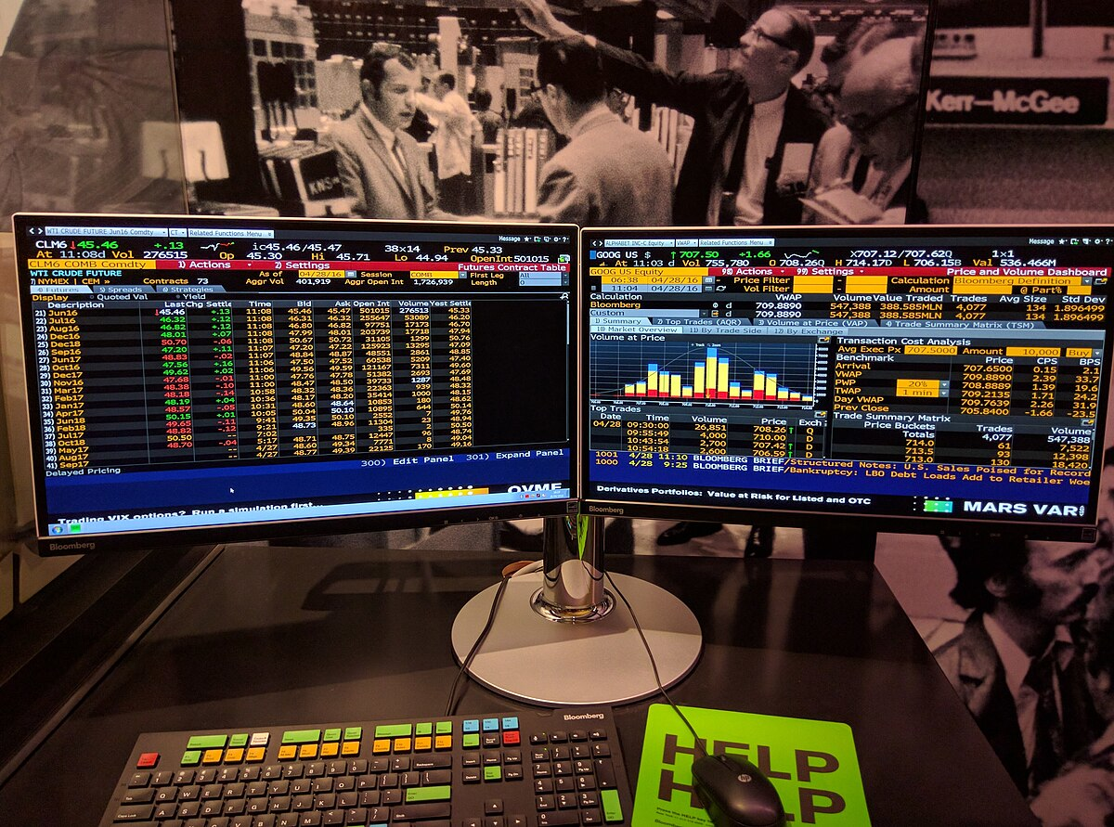

Example of a Bloomberg Terminal dual-screen dashboard displaying a detailed market overview with futures and stock trade data, useful for designing a post-close market dashboard in Excel.

**📊 Core Dashboard Structure**

**Header Section (Rows 1-4)**

MARKET OVERVIEW - POST CLOSE ANALYSIS  
Date: September 2, 2025 | Status: 🔴 CAUTION | Updated: 4:15 PM ET

**Main KPI Section (Rows 5-10)**

|  |  |  |  |
| --- | --- | --- | --- |
| **Index** | **Price** | **Change** | **After Hours** |
| **SPY** | 457.23 | -0.47% | -0.07% |
| **QQQ** | 385.67 | -1.11% | -0.19% |
| **IWM** | 198.45 | -0.49% | -0.17% |
| **VIX** | 16.20 | +8.0% | +0.62% |

**Market Signals Section (Rows 11-18)**

**GMI Components (Left):**

|  |  |  |  |  |
| --- | --- | --- | --- | --- |
| **Component** | **QQQ** | **SPY** | **IWM** | **Status** |
| Short-term Trend | 0 | 0 | 1 | Below 50MA |
| Trend Momentum | 0 | 0 | 1 | Declining |
| Long-term Trend | 1 | 1 | 1 | Above 150MA |
| Price Momentum | 1 | 0 | 1 | Mixed |
| **Total Score** | **2** | **1** | **4** | **2.3/4.0** |

**Breadth Indicators (Right):**

|  |  |  |  |
| --- | --- | --- | --- |
| **Indicator** | **Current** | **Previous** | **Status** |
| NYSE A/D | 1,247 | 1,523 | Weak |
| New 52W Highs | 43 | 67 | Declining |
| Net New Highs | -84 | -22 | Negative |
| McClellan Osc | -45.6 | -12.3 | Deteriorating |

**🔥 Sector Heatmap (Rows 19-25)**

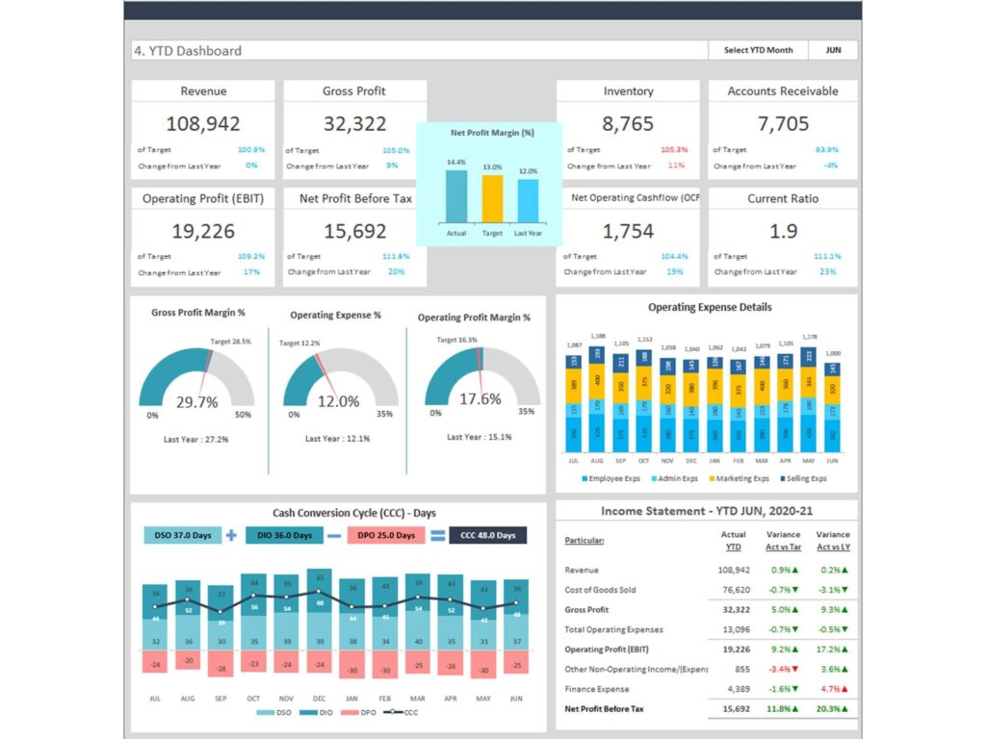

Year-to-date financial dashboard in Excel showing key metrics, charts, and income statement with mock data for market overview.

|  |  |  |  |  |
| --- | --- | --- | --- | --- |
| **Sector** | **Price** | **Change%** | **30D RS** | **Signal** |
| Energy (XLE) | 88.34 | +2.4% | 234.1 | 💪 STRONG |
| Technology (XLK) | 178.45 | +1.2% | 112.5 | 💪 STRONG |
| Communications (XLC) | 82.34 | +0.8% | 109.8 | ➡️ NEUTRAL |
| Utilities (XLU) | 67.89 | +1.1% | 87.6 | ➡️ NEUTRAL |
| Financials (XLF) | 38.67 | -1.8% | 45.6 | 🔻 WEAK |
| Materials (XLB) | 89.12 | -1.2% | 34.5 | 🔻 WEAK |

**📈 Top Movers Section (Rows 26-35)**

**Top Gainers:**

|  |  |  |  |  |
| --- | --- | --- | --- | --- |
| **Symbol** | **Price** | **Change%** | **Volume** | **AH Change** |
| NVDA | 134.67 | +4.2% | 45.2M | +0.5% |
| TSLA | 241.23 | +3.8% | 38.7M | -0.2% |
| AMD | 156.78 | +3.1% | 29.1M | +0.8% |

**Top Losers:**

|  |  |  |  |  |
| --- | --- | --- | --- | --- |
| **Symbol** | **Price** | **Change%** | **Volume** | **AH Change** |
| WMT | 78.23 | -2.8% | 12.3M | -0.1% |
| JNJ | 156.45 | -2.1% | 8.9M | +0.2% |
| PG | 167.89 | -1.9% | 6.7M | -0.4% |

**🎨 Professional Design Elements**

**Color Scheme:**

* **Header**: Dark Blue (#2C5282) with white text
* **Positive Values**: Light Green (#E6FFFA) background
* **Negative Values**: Light Red (#FFF5F5) background
* **Signal Indicators**: 🟢🟡🔴 for instant visual feedback

**Key Excel Formulas:**

Market Signal: =IF(AND(C5>0,D5>0,E5>0),"🟢 BULLISH",IF(AND(C5<0,D5<0,E5<0),"🔴 BEARISH","🟡 MIXED"))  
  
GMI Score: =IF(GMI_Score>=3,"🟢 GREEN",IF(GMI_Score<=1,"🔴 RED","🟡 NEUTRAL"))  
  
Risk Level: =IF(VIX>20,"🔴 HIGH",IF(VIX>15,"🟡 MODERATE","🟢 LOW"))

**📋 Complete Data Files**

I've created 8 CSV files with mock data ready for Excel import:

**🔧 Implementation Guide**

**🎯 Why This Design Works**

1. **Executive Focus**: Key information in the top 10 rows for quick scanning
2. **Institutional Standards**: Uses GMI, breadth indicators, and sector rotation analysis
3. **Visual Hierarchy**: Color coding and layouts guide the eye to critical information
4. **Scalable Architecture**: Easily expandable with additional indicators or markets
5. **Post-Close Optimization**: Includes after-hours data and next-day preparation elements

This dashboard design combines the sophistication of institutional trading desks with Excel's accessibility, providing a comprehensive market overview that supports both strategic decision-making and tactical trading decisions after market close.

⁂

1. Moving-Average-Cycles-Indicator-by-ChartingCycles-TradingView.html

1. NASI-Indicator-by-Ollie_AllCaps-TradingView.html

1. 145a46ea-439e-40c2-b9ee-6bbb24edf4c2_1021x532.jpg

1. <https://leanexcelsolutions.com/trading-portfolio-dashboard-in-excel/>

1. <https://www.rbcdirectinvesting.com/trading-tools-research/pre-market-after-hours-trading.html>

1. <https://www.saravalindustries.com/which-layout-is-right-for-your-trading-floor/>

1. <https://templatelab.com/excel-dashboards/>

1. <https://www.reddit.com/r/fidelityinvestments/comments/1e50j67/after_hours_trading_price_view_on_desktop/>

1. <https://www.investopedia.com/articles/investing/022416/different-trading-desks-investment-bank.asp>

1. <https://support.microsoft.com/en-au/office/create-and-share-a-dashboard-with-excel-and-microsoft-groups-ad92a34d-38d0-4fdd-b8b1-58379aae746e>

1. <https://www.nasdaq.com/market-activity/after-hours>

1. MARKET_PULSE_RESEARCH_DOCUMENTATION.md

1. <https://www.investglass.com/setting-up-a-trading-desk-from-interest-rate-swaps-to-foreign-exchange-trading-desks/>

1. <https://www.thesmallman.com/dashboards>

1. <https://www.barchart.com/stocks/post-market-trading>

1. <https://tickeron.com/trading-investing-101/what-is-the-definition-of-a-trading-desk/>

1. <https://www.oviond.com/the-best-excel-marketing-dashboard-templates/>

1. <https://marketchameleon.com/Reports/AfterHoursTrading>

1. <https://www.sbfi-financial.com/why-a-trading-desk/>

1. <https://chandoo.org/wp/excel-dashboards/>

1. <https://stockanalysis.com/markets/afterhours/>

1. <https://ppl-ai-code-interpreter-files.s3.amazonaws.com/web/direct-files/f3629e3fac2ae51debfff14627fc0b26/27337857-1963-455c-acc8-f5391d01c29b/85f89a74.csv>

1. Chilllax-Moving-Averages-with-Qullamaggie-colors-Indicator-by-chilllaxtrader-TradingView.html

1. <https://ppl-ai-code-interpreter-files.s3.amazonaws.com/web/direct-files/f3629e3fac2ae51debfff14627fc0b26/27337857-1963-455c-acc8-f5391d01c29b/c43cc7ef.csv>

1. <https://ppl-ai-code-interpreter-files.s3.amazonaws.com/web/direct-files/f3629e3fac2ae51debfff14627fc0b26/27337857-1963-455c-acc8-f5391d01c29b/8835383c.csv>

1. <https://ppl-ai-code-interpreter-files.s3.amazonaws.com/web/direct-files/f3629e3fac2ae51debfff14627fc0b26/27337857-1963-455c-acc8-f5391d01c29b/307c700c.csv>

1. <https://ppl-ai-code-interpreter-files.s3.amazonaws.com/web/direct-files/f3629e3fac2ae51debfff14627fc0b26/27337857-1963-455c-acc8-f5391d01c29b/c11e1220.csv>

1. <https://ppl-ai-code-interpreter-files.s3.amazonaws.com/web/direct-files/f3629e3fac2ae51debfff14627fc0b26/27337857-1963-455c-acc8-f5391d01c29b/ab3552f1.csv>

1. <https://ppl-ai-code-interpreter-files.s3.amazonaws.com/web/direct-files/f3629e3fac2ae51debfff14627fc0b26/27337857-1963-455c-acc8-f5391d01c29b/04b4a04b.csv>

1. <https://ppl-ai-code-interpreter-files.s3.amazonaws.com/web/direct-files/f3629e3fac2ae51debfff14627fc0b26/27337857-1963-455c-acc8-f5391d01c29b/9ea23ad3.csv>

1. <https://ppl-ai-code-interpreter-files.s3.amazonaws.com/web/direct-files/f3629e3fac2ae51debfff14627fc0b26/45654ccb-d567-4dc8-8702-9aea855a083a/d55a250d.md>

1. About-the-General-Market-Index-GMI-_-Wishing-Wealth-Blog.html

1. Copy-of-Daily-Economic-Numbers.xlsx

1. Net-New-Highs_Lows-With-visible-code-Indicator-by-Fred6724-TradingView.html

1. 1-8_18_25-Solar-Strength-Energy-Awakens.html

1. to_do

1. gmi_calculator.py